Sketch 2 (9/13/16)

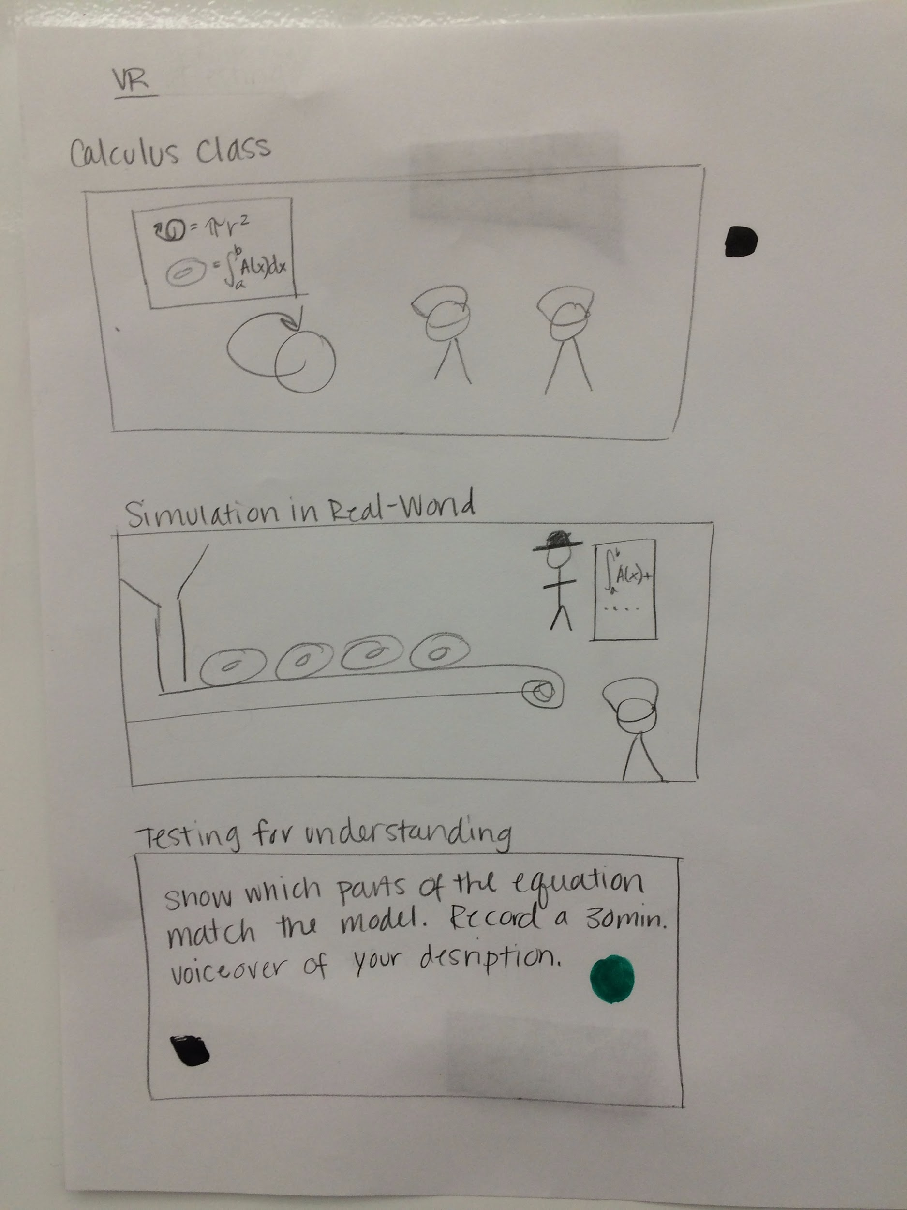

1. Students see a 3-D representation of a figure, and the corresponding mathematical equations.
2. Students are taken to a place where the equation and concept is used in real life.
3. Students are tested by teaching someone else what they know.